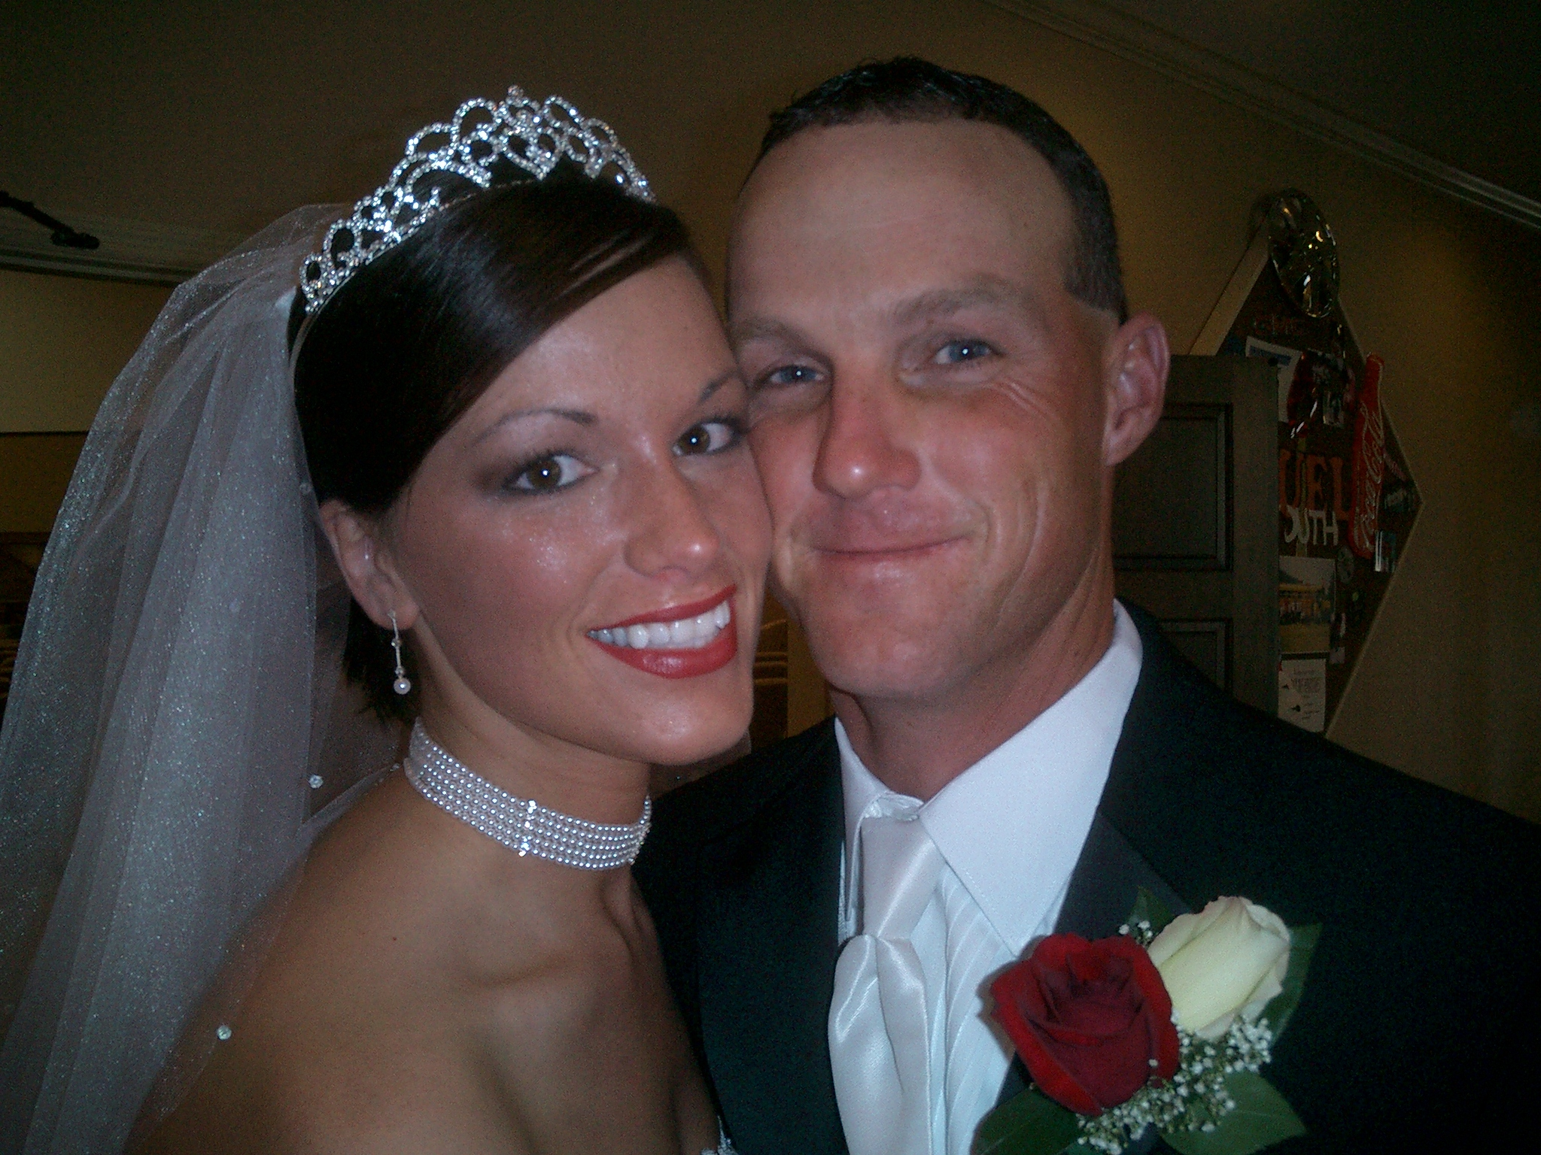
The wedding celebration
of
Laura Swain Keely
Ryan Matthew Middleton
and
Saturday, July 9, 2005
First Baptist Church
Murphy, North Carolina
A Note from the Bride and Groom
At this second appearing to take the oath of the presidential office, there is less occasion for an extended address than there was at the first. Then a statement, somewhat in detail, of a course to be pursued, seemed fitting and proper. Now, at the expiration of four years, during which public declarations have been constantly called forth on every point and phase of the great contest which still absorbs the attention, and engrosses the energies of the nation, little that is new could be presented.
The progress of our arms, upon which all else chiefly depends, is as well known to the public as to myself; and it is, I trust, reasonably satisfactory and encouraging to all. With high hope for the future, no prediction in regard to it is ventured.
On the occasion corresponding to this four years ago, all thoughts were anxiously directed to an impending civil war. All dreaded it--all sought to avert it. While the inaugural [sic] address was being delivered from this place, devoted altogether to saving the Union without war, insurgent agents were in the city seeking to destroy it without war--seeking to dissolve [sic] the Union, and divide effects, by negotiation. Both parties deprecated war; but one of them would make war rather than let the nation survive; and the other would accept war rather than let it perish. And the war came.

“Entreat me not to leave thee, or to return from following after thee. For whither thou goest, I will go.And where thou lodgest, I will lodge. Thy people shall be my people and thy God my God.” -Ruth 1:16
The candles are lit in memory of
Judy Laud, Opal Nelson, Locket Penland,
Paxil Clinton, Roy Malakin, and Elvis.
1
8
Order of Worship
Prelude
Seating of Honorary Bridesmaids
Seek Ye FirstK. Lafferty
Seating of the Grandmothers
Jesu, Joy of Man’s DesiringJ.S. Bach
Seating of the Mothers
Adaigo CantibileJ.S. Bach
Solo
The Lord’s PrayerMalotte
The Call to Worship
The Hymn of Praise
All Creatures of Our God and KingLasst
The Procession of the Wedding Party
National HymnW. Warren
AriosoJ.S. Bach
The Presentation of the Bride
Ceremony of Marriage
Declaration of Purpose
Questions
Prayer for Sincerity
Giving of the Bride in Marriage
The Vows
Giving and Receiving of Rings
Scripture Lesson
The Homily
Communion
Lighting of Unity Candle
Blessing of Marriage
Declaration of Marriage
Wedding Prayer
Benediction
Recessional
Toccata in F (from Symphony No. 5)C.M. Widin
2
7
Meet the Groomsmen
John Brisben, Friend of the Groom. Julie and Laura met their freshmen year of college and have been close friends ever since. Their friendship even survived a year of being roommates! Now they are each other’s Maids of Honor (Julie’s tying the knot this December!). Julie is 5’1” of fun, love, energy, and grace. Plus, she can run 27 kilometers around the city of Philadelphia. Just ask her...

Harry Gaither, Friend of the Groom. Julie and Laura met their freshmen year of college and have been close friends ever since. Their friendship even survived a year of being roommates! Now they are each other’s Maids of Honor (Julie’s tying the knot this December!). Julie is 5’1” of fun, love, energy, and grace. Plus, she can run 27 kilometers around the city of Philadelphia. Just ask her...

Bob Shellenberger, Brother of the Bride. Julie and Laura met their freshmen year of college and have been close friends ever since. Their friendship even survived a year of being roommates! Now they are each other’s Maids of Honor (Julie’s tying the knot this December!). Julie is 5’1” of fun, love, energy, and grace. Plus, she can run 27 kilometers around the city of Philadelphia. Just ask her...

Mika Griffin, Friend of the Groom. Julie and Laura met their freshmen year of college and have been close friends ever since. Their friendship even survived a year of being roommates! Now they are each other’s Maids of Honor (Julie’s tying the knot this December!). Julie is 5’1” of fun, love, energy, and grace. Plus, she can run 27 kilometers around the city of Philadelphia. Just ask her...

Todd Bush, Friend of the Groom. Julie and Laura met their freshmen year of college and have been close friends ever since. Their friendship even survived a year of being roommates! Now they are each other’s Maids of Honor (Julie’s tying the knot this December!). Julie is 5’1” of fun, love, energy, and grace. Plus, she can run 27 kilometers around the city of Philadelphia. Just ask her...

Zeff Decker, Friend of the Groom. Julie and Laura met their freshmen year of college and have been close friends ever since. Their friendship even survived a year of being roommates! Now they are each other’s Maids of Honor (Julie’s tying the knot this December!). Julie is 5’1” of fun, love, energy, and grace. Plus, she can run 27 kilometers around the city of Philadelphia. Just ask her...
5
4
Officiant
Reverend Doctor Thomas Mark Verdery

Parents of the Bride
Dr. and Mrs. David Fulmer Ralk, III

Parents of the Groom
Mr. and Mrs. Mark Douglas Middleton

Grandparents of the Bride
Mr. and Mrs. Oliver Sabold Ralk, II

Grandparents of the Groom
Mr. and Mrs. William Karl Miller
Reverend and Mrs. George Grenville Middleton

The Wedding Party

Maid of Honor
Miss Anna Williams Ralk

Bridesmaids
Miss Kelly Brooke Corner Mrs. Jill Treadwell Denman
Miss Christine Carol Gelona Miss Lisa Marie Middleton
Mrs. Katie Cook Porter

Best Man
Mr. Jeff John Karram

Groomsmen
Mr. Jason Michael AndersonMr. Robert Scott Ferdinand
Mr. David Lewis Rant Mr. Michael William George, Jr.
Mr. William Gilbert Scott
Honorary Bridesmaids
Miss Sara Cantrell Doggett
Mrs. Stacey Wright Gantt

Greeters
Miss Kristin Jane Holder
Master Harris Tommy Crisp
Master Root Akron Sabold

Organist
Mr. David Eugene Turner

Soloist
Miss Jennifer Lynn McDaniel

Acolytes
Master Canon Hayes Spradley
Master Julius Odell Spradford, III

Bell Ringers
Mr. Canon Hayes Spradley
Master Julius Odell Spradford, III

Wedding Directors
Mrs. Dorothy Hayes Amick
Mrs. Deborah Amick Fightberry

The reception will be held immediately afterward
in the Magnolia Room at Laurel Creek

Reception Greeters
Mr. and Mrs. Faulton Lane Bradley
Dr. and Mrs. Weston Gates Jobs, Jr.
Mr. and Mrs. Steve Hayes Amick
Mr. and Mrs. Bill Amend Crowe

