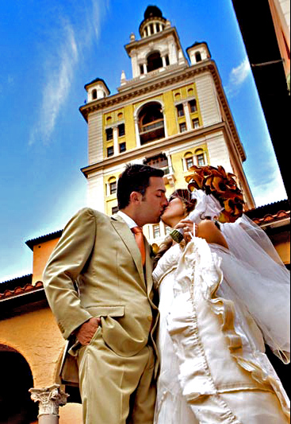

The wedding celebration
of
Gina Elise

David Michelangelo
and
Saturday, October 17th 2005
Holy Family Catholic Church
Murphy, North Carolina
A Note from the Bride and Groom
At this second appearing to take the oath of the presidential office, there is less occasion for an extended address than there was at the first. Then a statement, somewhat in detail, of a course to be pursued, seemed fitting and proper. Now, at the expiration of four years, during which public declarations have been constantly called forth on every point and phase of the great contest which still absorbs the attention, and engrosses the energies of the nation, little that is new could be presented.
The progress of our arms, upon which all else chiefly depends, is as well known to the public as to myself; and it is, I trust, reasonably satisfactory and encouraging to all. With high hope for the future, no prediction in regard to it is ventured.
On the occasion corresponding to this four years ago, all thoughts were anxiously directed to an impending civil war. All dreaded it--all sought to avert it. While the inaugural [sic] address was being delivered from this place, devoted altogether to saving the Union without war, insurgent agents were in the city seeking to destroy it without war--seeking to dissolve [sic] the Union, and divide effects, by negotiation. Both parties deprecated war; but one of them would make war rather than let the nation survive; and the other would accept war rather than let it perish. And the war came.

“Entreat me not to leave thee, or to return from following after thee. For whither thou goest, I will go. And where thou lodgest, I will lodge. Thy people shall be my people and thy God my God.” -Ruth 1:16
The candles are lit in memory of
Judy Laud, Opal Nelson, Locket Penland,
Paxil Clinton, Roy Malakin, and Elvis.
1
8

Order of Worship
Prelude

Ave Maria Schubert

Processional
Canon In D, “Pachelbel
Liturgy of the Word
FIRST READING: SONG OF SONGS 2:8-10, 14, 16A; 8:6-7ARESPONSORIAL PSALM (#328), ARR. MOORE
SECOND READING: 1 CORINTHIANS 12:31-13:8A
GOSPEL ACCLAMATION “CELTIC ALLELUIA”
GOSPEL READING: 1 JOHN 4:7-12
HOMILY

Liturgy of Marriage
EXCHANGE OF CONSENT AND WEDDING VOWS
BLESSING AND EXCHANGE OF RINGS

Prayers of the Faithful

Liturgy of the Eucharist
PREPARATION OF GIFTS “AUTHOR OF LOVE,” P. CLARK
EUCHARISTIC PRAYER

Communion Rite
RITE OF PEACE “AWAY IN A MANGER,” ARR. COTTER
COMMUNION . (#631), – FR. M. JONCAS

Concluding Rite
HOMAGE TO THE HOLY FAMILY “AVE MARIA,” SCHUBERT

Benediction
HOMAGE TO OUR LADY MARY “LITANY OF THE BLESSED VIRGIN”

Recessional
“HALLELUJAH CHORUS” FROM MESSIAH, HANDEL ARR. M. MARTIN

Ushers
DREW HAYNES
DARYL GARNER
HENRY ELSTON

Readers
DAVE ESIASON
CASSANDRA LANKFORD
MARSHA KULP
COURTNEY WOODS
SANDRA BARNARD

2
7
Gifts, Programs
ALLISON GINN
CALEY GINN
HENRY ELSTON

Vocalists
DARYL GARNER
HENRY ELSTON
MONISA GARNER
LISA GUILFORD
5
4
Vessel of honor,
Singular vessel of devotion,
Mystical rose,
Tower of David,
Tower of ivory,
House of gold,
Ark of the covenant,
Gate of heaven,
Morning star,
Health of the sick,
Refuge of sinners,
Comforter of the afflicted,
Help of Christians,
Queen of angels,
Queen of partiarchs,
Queen of prophets,
Queen of apostles,
Queen of martyrs,
Queen of confessors,
Queen of virgins,
Queen of all saints,
Queen conceived without original sin,
Queen assumed into heaven,
Queen of the most holy Rosary,
Queen of families,
Queen of peace,

Lamb of God, You take away
sins of the world;
spare us, O Lord.

Lamb of God, You take away
the sins of the world;
graciously hear us, O Lord.

Lamb of God, Your take away
the sins of the world;
have mercy on us.

V. Pray for us, O Holy Mother of God.

R. That we may be made worthy of the promises of Christ.

Let us pray.
Grant, we beg you, O Lord God, that we your servants may enjoy lasting health of mind and body, and by the glorious intercession of the Blessed Mary, ever Virgin,be delivered from present sorrow and enter into the joy of eternal happiness.

Through Christ our Lord.

R. Amen.

Let us pray.

O God,
you willed that, at the message of an angel,
your word should take flesh
in the womb of the Blessed Virgin Mary;
grant to your suppliant people,
that we, who believe her to be truly the Mother of God,
may be helped by her intercession with you.
Through the same Christ our Lord.

R. Amen.

Officiant
Reverend Doctor Thomas Mark Verdery

Parents of the Bride
Dr. and Mrs. David Fulmer Ralk, III

Parents of the Groom
Mr. and Mrs. Mark Douglas Middleton

The reception will be held immediately afterward
in the Magnolia Room at Laurel Creek

